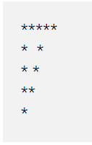

/\*\*

\* C program to print hollow inverted right triangle star pattern

\*/

#include <stdio.h>

int main()

{

int i, j, rows;

/\* Input number of rows from user \*/

printf("Enter number of rows: ");

scanf("%d", &rows);

/\* Iterate through rows \*/

for(i=1; i<=rows; i++)

{

/\* Iterate through columns \*/

for(j=i; j<=rows; j++)

{

/\*

\* Print stars for first row(i==1),

\* first column(j==1) and

\* last column(j=rows).

\*/

if(i==1 || j==i || j==rows)

{

printf("\*");

}

else

{

printf(" ");

}

}

/\* Move to next line \*/

printf("\n");

}

return 0;

}

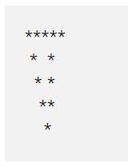

/\*\*

\* C program to print hollow mirrored inverted right triangle star pattern

\*/

#include <stdio.h>

int main()

{

int i, j, rows;

/\* Input rows to print from user \*/

printf("Enter number of rows : ");

scanf("%d", &rows);

for(i=1; i<=rows; i++)

{

/\* Print leading spaces \*/

for(j=1; j<i; j++)

{

printf(" ");

}

/\* Print hollow inverted right triangle \*/

for(j=i; j<=rows; j++)

{

/\*

\* Print star for ith column(j==i),

\* last column(j==rows) and for

\* first row(i==1).

\*/

if(j==i || j==rows || i==1)

{

printf("\*");

}

else

{

printf(" ");

}

}

printf("\n");

}

return 0;

}

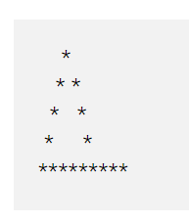

/\*\*

\* C program to print hollow pyramid triangle star pattern

\*/

#include <stdio.h>

int main()

{

int i, j, rows;

/\* Input rows to print from user \*/

printf("Enter number of rows : ");

scanf("%d", &rows);

for(i=1; i<=rows; i++)

{

/\* Print trailing spaces \*/

for(j=i; j<rows; j++)

{

printf(" ");

}

/\* Print hollow pyramid \*/

for(j=1; j<=(2\*i-1); j++)

{

/\*

\* Print star for last row (i==rows),

\* first column(j==1) and for

\* last column (j==(2\*i-1)).

\*/

if(i==rows || j==1 || j==(2\*i-1))

{

printf("\*");

}

else

{

printf(" ");

}

}

/\* Move to next line \*/

printf("\n");

}

return 0;

}

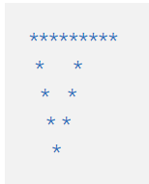

/\*\*

\* C program to print hollow inverted pyramid star pattern

\*/

#include <stdio.h>

int main()

{

int i, j, rows;

/\* Input rows to print from user \*/

printf("Enter number of rows: ");

scanf("%d", &rows);

/\* Iterate through rows \*/

for(i=1; i<=rows; i++)

{

/\* Print leading spaces \*/

for(j=1; j<i; j++)

{

printf(" ");

}

/\* Print hollow pyramid \*/

for(j=1; j<=(rows\*2 - (2\*i-1)); j++)

{

/\*

\* Print star for first row(i==1),

\* ith column (j==1) and for

\* last column (rows\*2-(2\*i-1))

\*/

if(i==1 || j==1 || j==(rows\*2 - (2\*i - 1)))

{

printf("\*");

}

else

{

printf(" ");

}

}

/\* Move to next line \*/

printf("\n");

}

return 0;

}



/\*\*

\* C program to print half diamond star pattern series.

\*/

#include<stdio.h>

int main()

{

int i, j, N, columns;

/\* Input number of columns from user \*/

printf("Enter number of columns:");

scanf("%d",&N);

columns=1;

for(i=1;i<N\*2;i++)

{

for(j=1; j<=columns; j++)

{

printf("\*");

}

if(i < N)

{

/\* Increment number of columns per row for upper part \*/

columns++;

}

else

{

/\* Decrement number of columns per row for lower part \*/

columns--;

}

/\* Move to next line \*/

printf("\n");

}

return 0;

}



/\*\*

\* C program to print mirrored half diamond star pattern

\*/

#include <stdio.h>

int main()

{

int i, j, N;

int star, spaces;

/\* Input number of columns to print from user \*/

printf("Enter number of columns : ");

scanf("%d", &N);

spaces = N-1;

star = 1;

/\* Iterate through rows \*/

for(i=1; i<N\*2; i++)

{

/\* Print leading spaces \*/

for(j=1; j<=spaces; j++)

printf(" ");

/\* Print stars \*/

for(j=1; j<=star; j++)

printf("\*");

/\* Move to next line \*/

printf("\n");

if(i < N)

{

star++;

spaces--;

}

else

{

star--;

spaces++;

}

}

return 0;

}

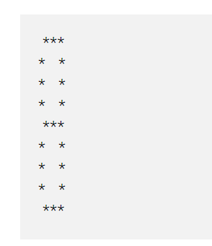

/\*\*

\* C program to print 8 star pattern series

\*/

#include <stdio.h>

int main()

{

int i, j, size;

printf("Enter size: ");

scanf("%d", &size);

for(i=1; i<size\*2; i++)

{

for(j=1; j<=size; j++)

{

// Condition for corner and center intersection space

if((i==1 && (j==1 || j==size)) ||

(i==size && (j==1 || j==size)) ||

(i==size\*2-1 && (j==1 || j==size)))

{

printf(" ");

}

else if(i==1 || i==size || i==(size\*2)-1 || j==1 || j==size)

{

printf("\*");

}

else

{

printf(" ");

}

}

printf("\n");

}

return 0;

}

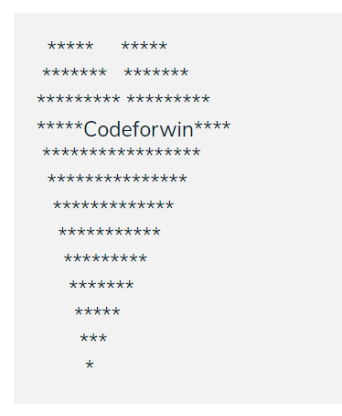

/\*\*

\* C program to print heart star pattern with center name

\*/

#include <stdio.h>

#include <string.h>

int main()

{

int i, j, n;

char name[50];

int len;

printf("Enter your name: ");

gets(name);

printf("Enter value of n : ");

scanf("%d", &n);

len = strlen(name);

// Print upper part of the heart shape

for(i=n/2; i<=n; i+=2)

{

for(j=1; j<n-i; j+=2)

{

printf(" ");

}

for(j=1; j<=i; j++)

{

printf("\*");

}

for(j=1; j<=n-i; j++)

{

printf(" ");

}

for(j=1; j<=i; j++)

{

printf("\*");

}

printf("\n");

}

// Prints lower triangular part of the pattern

for(i=n; i>=1; i--)

{

for(j=i; j<n; j++)

{

printf(" ");

}

// Print the name

if(i == n)

{

for(j=1; j<=(n \* 2-len)/2; j++)

{

printf("\*");

}

printf("%s", name);

for(j=1; j<(n\*2-len)/2; j++)

{

printf("\*");

}

}

else

{

for(j=1; j<=(i\*2)-1; j++)

{

printf("\*");

}

}

printf("\n");

}

return 0;

}

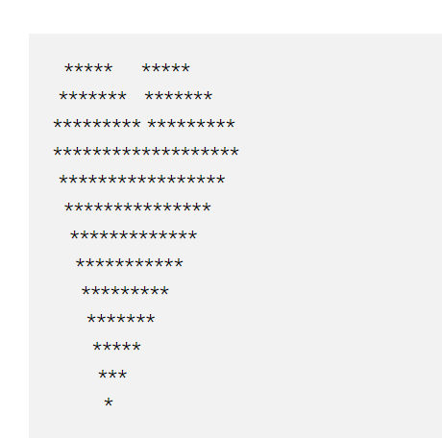

/\*\*

\* C program to print heart star pattern

\*/

#include <stdio.h>

int main()

{

int i, j, n;

printf("Enter value of n : ");

scanf("%d", &n);

for(i=n/2; i<=n; i+=2)

{

for(j=1; j<n-i; j+=2)

{

printf(" ");

}

for(j=1; j<=i; j++)

{

printf("\*");

}

for(j=1; j<=n-i; j++)

{

printf(" ");

}

for(j=1; j<=i; j++)

{

printf("\*");

}

printf("\n");

}

for(i=n; i>=1; i--)

{

for(j=i; j<n; j++)

{

printf(" ");

}

for(j=1; j<=(i\*2)-1; j++)

{

printf("\*");

}

printf("\n");

}

return 0;

}

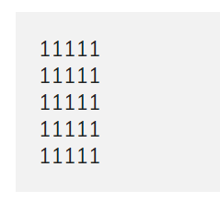

/\*\*

\* C program to print square number pattern

\*/

#include <stdio.h>

int main()

{

int rows, cols, i, j;

/\* Input rows and columns from user \*/

printf("Enter number of rows: ");

scanf("%d", &rows);

printf("Enter number of columns: ");

scanf("%d", &cols);

/\* Iterate through rows \*/

for(i=1; i<=rows; i++)

{

/\* Iterate through columns \*/

for(j=1; j<=cols; j++)

{

printf("1");

}

printf("\n");

}

return 0;

}

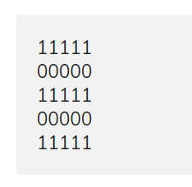

/\*\*

\* C program to print number pattern of 1, 0 at even/odd rows

\*/

#include <stdio.h>

int main()

{

int rows, cols, i, j;

/\* Input rows and columns from user \*/

printf("Enter number of rows: ");

scanf("%d", &rows);

printf("Enter number of columns: ");

scanf("%d", &cols);

for(i=1; i<=rows; i++)

{

for(j=1; j<=cols; j++)

{

// Print 1 if current row is odd

if(i%2 == 1)

{

printf("1");

}

else

{

printf("0");

}

}

printf("\n");

}

return 0;

}

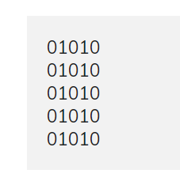

/\*\*

\* C program to print number pattern with 1/0 at even/odd position

\*/

#include <stdio.h>

int main()

{

int rows, cols, i, j;

/\* Input rows and columns from user \*/

printf("Enter number of rows: ");

scanf("%d", &rows);

printf("Enter number of columns: ");

scanf("%d", &cols);

for(i=1; i<=rows; i++)

{

for(j=1; j<=cols; j++)

{

// Print 1 if current column is even

if(j%2 == 1)

{

printf("0");

}

else

{

printf("1");

}

}

printf("\n");

}

return 0;

}

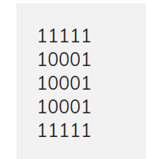

/\*\*

\* C program to print box number pattern of 1's and 0's

\*/

#include <stdio.h>

int main()

{

int rows, cols, i, j;

/\* Input rows and columns from user \*/

printf("Enter number of rows: ");

scanf("%d", &rows);

printf("Enter number of columns: ");

scanf("%d", &cols);

for(i=1; i<=rows; i++)

{

for(j=1; j<=cols; j++)

{

/\*

\* Print 1 if its first or last row

\* Print 1 if its first or last column

\*/

if(i==1 || i==rows || j==1 || j==cols)

{

printf("1");

}

else

{

printf("0");

}

}

printf("\n");

}

return 0;

}

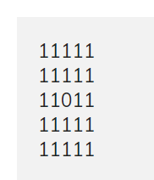

/\*\*

\* C program to print box number pattern of 1's with 0 as center

\*/

#include <stdio.h>

int main()

{

int rows, cols, i, j;

int centerRow, centerCol;

/\* Input rows and columns from user \*/

printf("Enter number of rows: ");

scanf("%d", &rows);

printf("Enter number of columns: ");

scanf("%d", &cols);

/\* Find center row and column \*/

centerRow = (rows + 1) / 2;

centerCol = (cols + 1) / 2;

for(i=1; i<=rows; i++)

{

for(j=1; j<=cols; j++)

{

if(centerCol == j && centerRow == i)

{

printf("0");

}

else if(cols%2 == 0 && centerCol+1 == j)

{

if(centerRow == i || (rows%2 == 0 && centerRow+1 == i))

printf("0");

else

printf("1");

}

else if(rows%2 == 0 && centerRow+1 == i)

{

if(centerCol == j || (cols%2 == 0 && centerCol+1 == j))

printf("0");

else

printf("1");

}

else

{

printf("1");

}

}

printf("\n");

}

return 0;

}

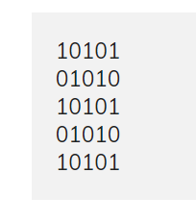

/\*\*

\* C program to print box number pattern with cross center

\*/

#include <stdio.h>

int main()

{

int rows, cols, i, j, k;

/\* Input rows and columns from user \*/

printf("Enter number of rows: ");

scanf("%d", &rows);

printf("Enter number of columns: ");

scanf("%d", &cols);

k = 1;

for(i=1; i<=rows; i++)

{

for(j=1; j<=cols; j++)

{

if(k == 1)

{

printf("1");

}

else

{

printf("0");

}

// If k = 1 then k \*= -1 => -1

// If k = -1 then k \*= -1 => 1

k \*= -1;

}

if(cols % 2 == 0)

{

k \*= -1;

}

printf("\n");

}

return 0;

}

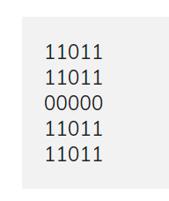

/\*\*

\* C program to print box number pattern with plus in center

\*/

#include <stdio.h>

int main()

{

int rows, cols, i, j;

int centerRow, centerCol;

/\* Input rows and columns from user \*/

printf("Enter number of rows: ");

scanf("%d", &rows);

printf("Enter number of columns: ");

scanf("%d", &cols);

centerRow = (rows+1) / 2;

centerCol = (cols+1) / 2;

for(i=1; i<=rows; i++)

{

for(j=1; j<=cols; j++)

{

// Print 0 for central rows or columns

if(centerCol == j || centerRow == i)

{

printf("0");

}

else if((cols%2 == 0 && centerCol+1 == j) || (rows%2 == 0 && centerRow+1 == i))

{

// Print an extra 0 for even rows or columns

printf("0");

}

else

{

printf("1");

}

}

printf("\n");

}

return 0;

}

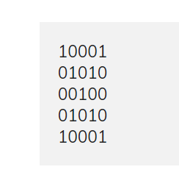

/\*\*

\* C program to print box number pattern with cross center

\*/

#include <stdio.h>

int main()

{

int rows, cols, i, j;

/\* Input rows and columns from user \*/

printf("Enter number of rows: ");

scanf("%d", &rows);

printf("Enter number of columns: ");

scanf("%d", &cols);

for(i=1; i<=rows; i++)

{

for(j=1; j<=cols; j++)

{

if(i == j || (j == (cols+1) - i))

{

printf("1");

}

else

{

printf("0");

}

}

printf("\n");

}

return 0;

}

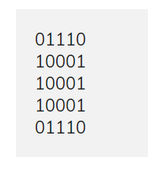

/\*\*

\* C program to print circle box number pattern

\*/

#include <stdio.h>

int main()

{

int i, j, rows, cols;

/\* Input rows and columns from user \*/

printf("Enter rows: ");

scanf("%d", &rows);

printf("Enter columns: ");

scanf("%d", &cols);

for(i=1; i<=rows; i++)

{

for(j=1; j<=cols; j++)

{

// Print corner element

if((i==1 || i==rows) && (j==1 || j==cols))

{

printf("0");

}

else if(i==1 || i==rows || j==1 || j==cols)

{

// Print edge

printf("1");

}

else

{

// Print center

printf("0");

}

}

printf("\n");

}

return 0;

}

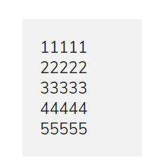

/\*\*

\* C program to print number pattern

\*/

#include <stdio.h>

int main()

{

int rows, cols, i, j;

/\* Input rows and columns from user \*/

printf("Enter number of rows: ");

scanf("%d", &rows);

printf("Enter number of columns: ");

scanf("%d", &cols);

for(i=1; i<=rows; i++)

{

for(j=1; j<=cols; j++)

{

// Print the current row number

printf("%d", i);

}

printf("\n");

}

return 0;

}

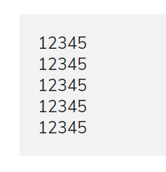

/\*\*

\* C program to print number pattern

\*/

#include <stdio.h>

int main()

{

int rows, cols, i, j;

/\* Input rows and columns from user \*/

printf("Enter number of rows: ");

scanf("%d", &rows);

printf("Enter number of columns: ");

scanf("%d", &cols);

for(i=1; i<=rows; i++)

{

for(j=1; j<=cols; j++)

{

// Print the current column number

printf("%d", j);

}

printf("\n");

}

return 0;

}

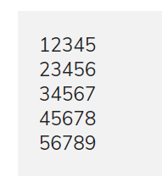

/\*\*

\* C program to print number pattern

\*/

#include <stdio.h>

int main()

{

int rows, cols, i, j;

/\* Input rows and columns from user

\*/

printf("Enter number of rows: ");

scanf("%d", &rows);

printf("Enter number of columns: ");

scanf("%d", &cols);

for(i=1; i<=rows; i++)

{

for(j=i; j < i+cols; j++)

{

printf("%d", j);

}

printf("\n");

}

return 0;

}

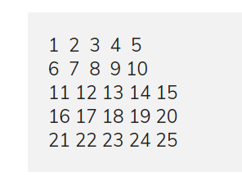

/\*\*

\* C program to print number pattern

\*/

#include <stdio.h>

int main()

{

int rows, cols, i, j, k;

/\* Input rows and columns from user \*/

printf("Enter number of rows: ");

scanf("%d", &rows);

printf("Enter number of columns: ");

scanf("%d", &cols);

k = 1;

for(i=1; i<=rows; i++)

{

for(j=1; j<=cols; j++, k++)

{

printf("%-3d", k);

}

printf("\n");

}

return 0;

}

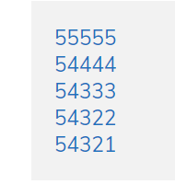

/\*\*

\* C program to print number pattern

\*/

#include <stdio.h>

int main()

{

int rows, cols, i, j;

/\* Input rows and columns from user

\*/

printf("Enter number of rows: ");

scanf("%d", &rows);

printf("Enter number of columns: ");

scanf("%d", &cols);

for(i=1; i<=rows; i++)

{

for(j=cols; j>cols-i; j--)

{

printf("%d", j);

}

for(j=1; j<=cols-i; j++)

{

printf("%d", (rows - i + 1));

}

printf("\n");

}

return 0;

}

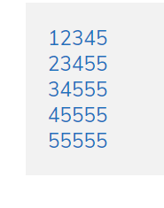

/\*\*

\* C program to print number pattern

\*/

#include <stdio.h>

int main()

{

int rows, cols, i, j;

/\* Input rows and columns from user \*/

printf("Enter number of rows: ");

scanf("%d", &rows);

printf("Enter number of columns: ");

scanf("%d", &cols);

for(i=1; i<=rows; i++)

{

for(j=i; j<=cols; j++)

{

printf("%d", j);

}

for(j=i; j>1; j--)

{

printf("%d", cols);

}

printf("\n");

}

return 0;

}

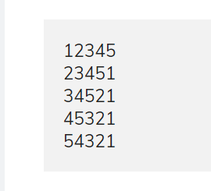

/\*\*

\* C program to print number pattern

\*/

#include <stdio.h>

int main()

{

int rows, cols, i, j;

/\* Input rows and columns from user \*/

printf("Enter number of rows: ");

scanf("%d", &rows);

printf("Enter number of columns: ");

scanf("%d", &cols);

for(i=1; i<=rows; i++)

{

for(j=i; j<=cols; j++)

{

printf("%d", j);

}

for(j=i-1; j>=1; j--)

{

printf("%d", j);

}

printf("\n");

}

return 0;

}

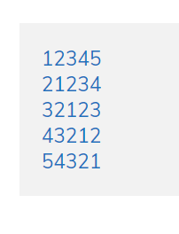

/\*\*

\* C program to print number pattern

\*/

#include <stdio.h>

int main()

{

int N, i, j;

printf("Enter N: ");

scanf("%d", &N);

for(i=1; i<=N; i++)

{

// Print first part

for(j=i; j>1; j--)

{

printf("%d", j);

}

// Print second part

for(j=1; j<= (N-i +1); j++)

{

printf("%d", j);

}

printf("\n");

}

return 0;

}

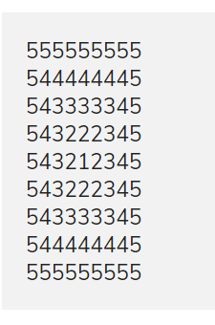

/\*\*

\* C program to print number pattern

\*/

#include <stdio.h>

int main()

{

int N, i, j;

printf("Enter N: ");

scanf("%d", &N);

// First upper half of the pattern

for(i=N; i>=1; i--)

{

// First inner part of upper half

for(j=N; j>i; j--)

{

printf("%d", j);

}

// Second inner part of upper half

for(j=1; j<=(i\*2-1); j++)

{

printf("%d", i);

}

// Third inner part of upper half

for(j=i+1; j<=N; j++)

{

printf("%d", j);

}

printf("\n");

}

// Second lower half of the pattern

for(i=1; i<N; i++)

{

// First inner part of lower half

for(j=N; j>i; j--)

{

printf("%d", j);

}

// Second inner part of lower half

for(j=1; j<=(i\*2-1); j++)

{

printf("%d", i+1);

}

// Third inner part of lower half

for(j=i+1; j<=N; j++)

{

printf("%d", j);

}

printf("\n");

}

return 0;

}

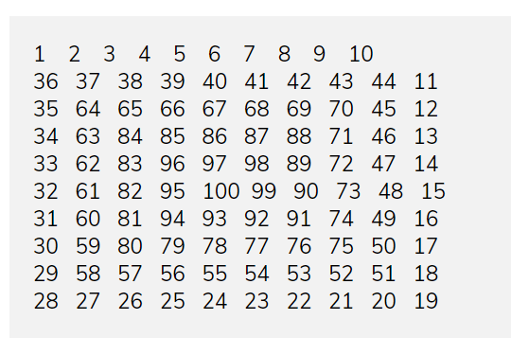

/\*\*

\* C program to print perfect square number pattern

\*/

#include <stdio.h>

#define SIZE 10 // Size is always even

int main()

{

int i, j, N;

int board[SIZE][SIZE];

int left, top;

left = 0;

top = SIZE - 1;

N = 1;

for(i=1; i<=SIZE/2; i++, left++, top--)

{

// Fill from left to right

for(j=left; j<=top; j++, N++)

{

board[left][j] = N;

}

// Fill from top to down

for(j=left+1; j<=top; j++, N++)

{

board[j][top] = N;

}

// Fill from right to left

for(j=top-1; j>=left; j--, N++)

{

board[top][j] = N;

}

// Fill from down to top

for(j=top-1; j>=left+1; j--, N++)

{

board[j][left] = N;

}

}

// Print the pattern

for(i=0; i<SIZE; i++)

{

for(j=0; j<SIZE; j++)

{

printf("%-5d", board[i][j]);

}

printf("\n");

}

return 0;

}

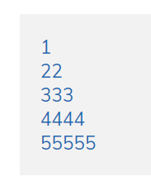

/\*\*

\* C program to print number pattern

\*/

#include <stdio.h>

int main()

{

int i, j, N;

printf("Enter N: ");

scanf("%d", &N);

for(i=1; i<=N; i++)

{

for(j=1; j<=i; j++)

{

printf("%d", i);

}

printf("\n");

}

return 0;

}

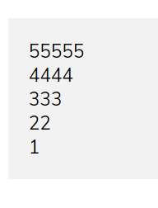

/\*\*

\* C program to print number pattern

\*/

#include <stdio.h>

int main()

{

int i, j, N;

printf("Enter N: ");

scanf("%d", &N);

for(i=N; i>=1; i--)

{

for(j=1; j<=i; j++)

{

printf("%d", i);

}

printf("\n");

}

return 0;

}

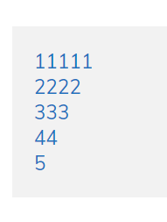 /\*\*

\* C program to print number pattern

\*/

#include <stdio.h>

int main()

{

int i, j, N;

printf("Enter N: ");

scanf("%d", &N);

for(i=1; i<=N; i++)

{

// Logic to print numbers

for(j=i; j<=N; j++)

{

printf("%d", i);

}

printf("\n");

}

return 0;

}

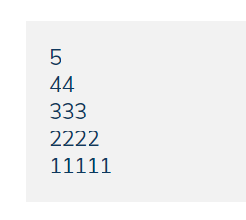

/\*\*

\* C program to print number pattern

\*/

#include <stdio.h>

int main()

{

int i, j, N;

printf("Enter N: ");

scanf("%d", &N);

for(i=1; i<=N; i++)

{

// Logic to print numbers

for(j=1; j<=i; j++)

{

printf("%d", (N - i + 1));

}

printf("\n");

}

return 0;

}

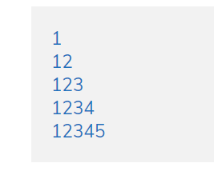

/\*\*

\* C program to print number pattern

\*/

#include <stdio.h>

int main()

{

int i, j, N;

printf("Enter N: ");

scanf("%d", &N);

for(i=1; i<=N; i++)

{

// Logic to print numbers

for(j=1; j<=i; j++)

{

printf("%d", j);

}

printf("\n");

}

return 0;

}

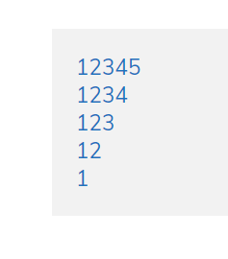

/\*\*

\* C program to print number pattern

\*/

#include <stdio.h>

int main()

{

int i, j, N;

printf("Enter N: ");

scanf("%d", &N);

for(i=1; i<=N; i++)

{

// Logic to print numbers

for(j=1; j<=N-i+1; j++)

{

printf("%d", j);

}

printf("\n");

}

return 0;

}

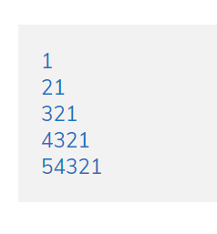

/\*\*

\* C program to print number pattern

\*/

#include <stdio.h>

int main()

{

int i, j, N;

printf("Enter N: ");

scanf("%d", &N);

for(i=1; i<=N; i++)

{

// Logic to print numbers

for(j=i; j>=1; j--)

{

printf("%d", j);

}

printf("\n");

}

return 0;

}

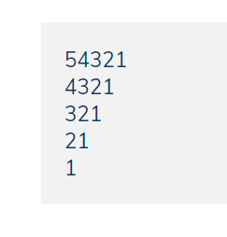

/\*\*

\* C program to print number pattern

\*/

#include <stdio.h>

int main()

{

int i, j, N;

printf("Enter N: ");

scanf("%d", &N);

for(i=N; i>=1; i--)

{

// Logic to print numbers

for(j=i; j>=1; j--)

{

printf("%d", j);

}

printf("\n");

}

return 0;

}

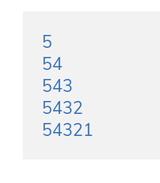

/\*\*

\* C program to print number pattern

\*/

#include <stdio.h>

int main()

{

int i, j, N;

printf("Enter N: ");

scanf("%d", &N);

for(i=N; i>=1; i--)

{

// Logic to print numbers

for(j=N; j>=i; j--)

{

printf("%d", j);

}

printf("\n");

}

return 0;

}

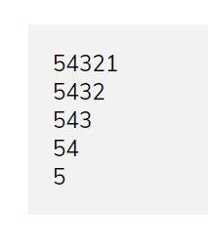.

/\*\*

\* C program to print number pattern

\*/

#include <stdio.h>

int main()

{

int i, j, N;

printf("Enter N: ");

scanf("%d", &N);

for(i=1; i<=N; i++)

{

// Logic to print numbers

for(j=N; j>=i; j--)

{

printf("%d", j);

}

printf("\n");

}

return 0;

}

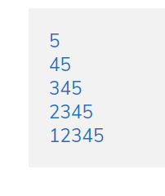

/\*\*

\* C program to print number pattern

\*/

#include <stdio.h>

int main()

{

int i, j, N;

printf("Enter N: ");

scanf("%d", &N);

for(i=N; i>=1; i--)

{

// Logic to print numbers

for(j=i; j<=N; j++)

{

printf("%d", j);

}

printf("\n");

}

return 0;

}

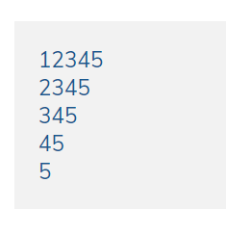

/\*\*

\* C program to print number pattern

\*/

#include <stdio.h>

int main()

{

int i, j, N;

printf("Enter N: ");

scanf("%d", &N);

for(i=1; i<=N; i++)

{

// Logic to print numbers

for(j=i; j<=N; j++)

{

printf("%d", j);

}

printf("\n");

}

return 0;

}

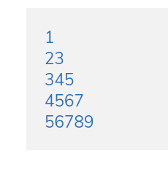

/\*\*

\* C program to print number pattern

\*/

#include <stdio.h>

int main()

{

int i, j, k, N;

printf("Enter N: ");

scanf("%d", &N);

for(i=1; i<=N; i++)

{

k = i;

// Logic to print numbers

for(j=1; j<=i; j++, k++)

{

printf("%d", k);

}

printf("\n");

}

return 0;

}

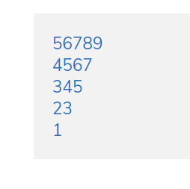

/\*\*

\* C program to print number pattern

\*/

#include <stdio.h>

int main()

{

int i, j, k, N;

printf("Enter N: ");

scanf("%d", &N);

for(i=N; i>=1; i--)

{

k = i;

// Logic to print numbers

for(j=1; j<=i; j++, k++)

{

printf("%d", k);

}

printf("\n");

}

return 0;

}

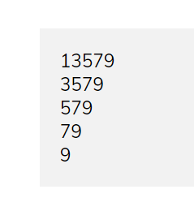

/\*\*

\* C program to print number pattern

\*/

#include <stdio.h>

int main()

{

int i, j, k, N;

printf("Enter N: ");

scanf("%d", &N);

for(i=1; i<=N; i++)

{

k = (i \* 2) - 1;

// Logic to print numbers

for(j=i; j<=N; j++, k+=2)

{

printf("%d", k);

}

printf("\n");

}

return 0;

}

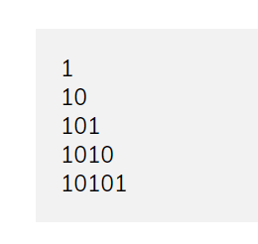

/\*\*

\* C program to print the given number pattern

\*/

#include <stdio.h>

int main()

{

int i, j, N;

printf("Enter N: ");

scanf("%d", &N);

for(i=1; i<=N; i++)

{

for(j=1; j<=i; j++)

{

// For every odd column print 1

if(j % 2 == 1)

{

printf("1");

}

else

{

printf("0");

}

}

printf("\n");

}

return 0;

}

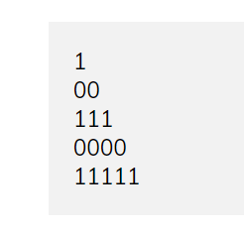

/\*\*

\* C program to print the given number pattern

\*/

#include <stdio.h>

int main()

{

int i, j, N;

printf("Enter N: ");

scanf("%d", &N);

for(i=1; i<=N; i++)

{

for(j=1; j<=i; j++)

{

// Print 1s for every odd rows

if(i % 2 == 1)

{

printf("1");

}

else

{

printf("0");

}

}

printf("\n");

}

return 0;

}

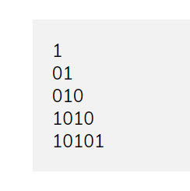

/\*\*

\* C program to print the given number pattern

\*/

#include <stdio.h>

int main()

{

int i, j, k, N;

printf("Enter N: ");

scanf("%d", &N);

// k represents the current integer

k = 1;

for(i=1; i<=N; i++)

{

for(j=1; j<=i; j++)

{

// Print 1 if current integer k is odd

if(k % 2 == 1)

{

printf("1");

}

else

{

printf("0");

}

k++;

}

printf("\n");

}

return 0;

}

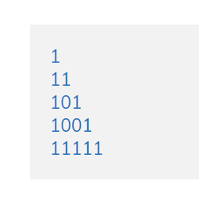

/\*\*

\* C program to print triangle 0, 1 number pattern

\*/

#include <stdio.h>

int main()

{

int i, j, N;

printf("Enter N: ");

scanf("%d", &N);

for(i=1; i<=N; i++)

{

for(j=1; j<=i; j++)

{

if(i==1 || i==N || j==1 || j==i)

{

printf("1");

}

else

{

printf("0");

}

}

printf("\n");

}

return 0;

}

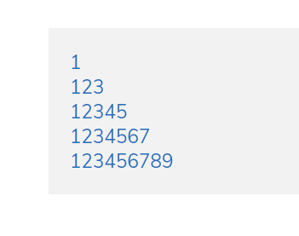

/\*\*

\* C program to print number pattern

\*/

#include <stdio.h>

int main()

{

int i, j, N;

printf("Enter N: ");

scanf("%d", &N);

for(i=1; i<=N; i++)

{

// Logic to print numbers

for(j=1; j<=(i\*2-1); j++)

{

printf("%d", j);

}

printf("\n");

}

return 0;

}

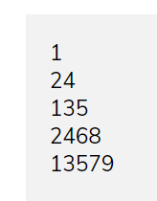

/\*\*

\* C program to print number pattern

\*/

#include <stdio.h>

int main()

{

int i, j, k, N;

printf("Enter N: ");

scanf("%d", &N);

for(i=1; i<=N; i++)

{

// Checking even or odd

if(i & 1)

k = 1;

else

k = 2;

// Logic to print numbers

for(j=1; j<=i; j++, k+=2)

{

printf("%d", k);

}

printf("\n");

}

return 0;

}

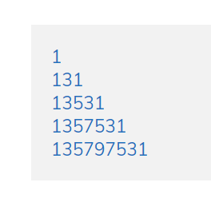

/\*\*

\* C program to print the given number pattern

\*/

#include <stdio.h>

int main()

{

int i, j, N;

printf("Enter rows: ");

scanf("%d", &N);

for(i=1; i<=N; i++)

{

// Prints the first part of pattern

for(j=1; j<=(i\*2)-1; j+=2)

{

printf("%d", j);

}

// Prints the second part of pattern

for(j=(i-1)\*2-1; j>=1; j-=2)

{

printf("%d", j);

}

printf("\n");

}

return 0;

}

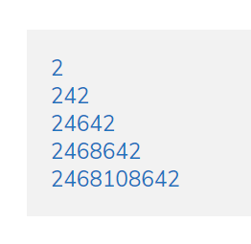

/\*\*

\* C program to print the given number pattern

\*/

#include <stdio.h>

int main()

{

int i, j, N;

printf("Enter rows: ");

scanf("%d", &N);

for(i=1; i<=N; i++)

{

// Prints first part of the pattern

for(j=2; j<=i\*2; j+=2)

{

printf("%d", j);

}

// Prints second part of the pattern

for(j=(i-1)\*2; j>=2; j-=2)

{

printf("%d", j);

}

printf("\n");

}

return 0;

}

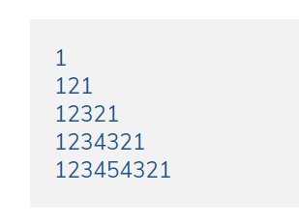

/\*\*

\* C program to print the given number pattern

\*/

#include <stdio.h>

int main()

{

int i, j, N;

printf("Enter rows: ");

scanf("%d", &N);

for(i=1; i<=N; i++)

{

// Prints the first part of the pattern

for(j=1; j<=i; j++)

{

printf("%d", j);

}

// Prints the second part of the pattern

for(j=i-1; j>=1; j--)

{

printf("%d", j);

}

printf("\n");

}

return 0;

}

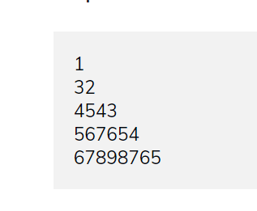

/\*\*

\* C program to print the given number pattern

\*/

#include <stdio.h>

int main()

{

int i, j, value, N;

printf("Enter rows: ");

scanf("%d", &N);

for(i=1; i<=N; i++)

{

value = i + 1;

// Prints the first part of pattern

for(j=3; j<=i; j++)

{

printf("%d ", value);

value++;

}

// Prints the second part of pattern

for(j=(i\*2)-1; j>=i; j--)

{

printf("%d ", j);

}

printf("\n");

}

return 0;

}

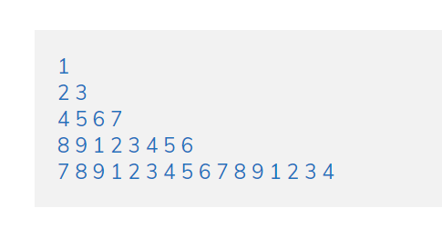

/\*\*

\* C program to print the given number pattern

\*/

#include <stdio.h>

int main()

{

int i, j, N, colCount, value;

colCount = 1;

value = 1;

printf("Enter rows: ");

scanf("%d", &N);

for(i=1; i<=N; i++)

{

for(j=1; j<=colCount; j++)

{

if(value == 10)

value = 1; // Restart at 10

printf("%d ", value);

value++;

}

printf("\n");

// Increase the total number of columns by 2

colCount \*= 2;

}

return 0;

}

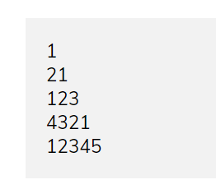

/\*\*

\* C program to print the given number pattern

\*/

#include <stdio.h>

int main()

{

int i, j, N;

printf("Enter rows: ");

scanf("%d", &N);

for(i=1; i<=N; i++)

{

if(i & 1)

{

// Print numbers for odd row

for(j=1; j<=i; j++)

{

printf("%d", j);

}

}

else

{

// Print numbers for even row

for(j=i; j>=1; j--)

{

printf("%d", j);

}

}

printf("\n");

}

return 0;

}

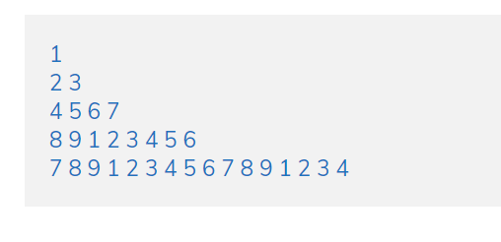

/\*\*

\* C program to print the given number pattern

\*/

#include <stdio.h>

int main()

{

int i, j, N, colCount, value;

colCount = 1;

value = 1;

printf("Enter rows: ");

scanf("%d", &N);

for(i=1; i<=N; i++)

{

for(j=1; j<=colCount; j++)

{

if(value == 10)

value = 1; // Restart at 10

printf("%d ", value);

value++;

}

printf("\n");

// Increase the total number of columns by 2

colCount \*= 2;

}

return 0;

}

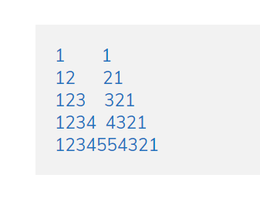

/\*\*

\* C program to print the given number pattern

\*/

#include <stdio.h>

int main()

{

int i, j, N;

printf("Enter rows: ");

scanf("%d", &N);

for(i=1; i<=N; i++)

{

// Prints first part of pattern

for(j=1; j<=i; j++)

{

printf("%d", j);

}

// Prints spaces between two parts

for(j=i\*2; j<N\*2; j++)

{

printf(" ");

}

// Prints second part of the pattern

for(j=i; j>=1; j--)

{

printf("%d", j);

}

printf("\n");

}

return 0;

}

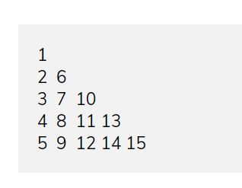

/\*\*

\* C program to print the given number pattern

\*/

#include <stdio.h>

int main()

{

int i, j, diff, value, N;

printf("Enter rows: ");

scanf("%d", &N);

for(i=1; i<=N; i++)

{

diff = N-1; // Initialize difference to total rows - 1

value = i; // Initialize value to the current row number

for(j=1; j<=i; j++)

{

printf("%-3d", value);

value += diff; // Computes the next value to be printed

diff--; // Decrements the difference

}

printf("\n");

}

return 0;

}

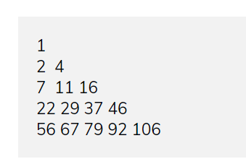

/\*\*

\* C program to print the given number pattern

\*/

#include <stdio.h>

int main()

{

int i, j, diff, value, N;

printf("Enter rows: ");

scanf("%d", &N);

diff = 1;

value = 1;

for(i=1; i<=N; i++)

{

for(j=1; j<=i; j++)

{

printf("%-3d", value);

value += diff; // Computes the next value to be printed

diff++; // Increments the difference

}

printf("\n");

}

return 0;

}

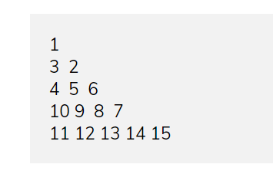

/\*\*

\* C program to print the given number pattern

\*/

#include <stdio.h>

int main()

{

int i, j, count, value, N;

printf("Enter rows: ");

scanf("%d", &N);

count = 0;

for(i=1; i<=N; i++)

{

// Starting value of column based on even or odd row.

value = (i & 1) ? (count + 1) : (count + i);

for(j=1; j<=i; j++)

{

printf("%-3d", value);

// Increment the value for odd rows

if(i & 1)

value++;

else

value--;

count++;

}

printf("\n");

}

return 0;

}

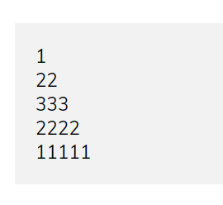

/\*\*

\* C program to print the given number pattern

\*/

#include <stdio.h>

int main()

{

int i, j, N;

printf("Enter rows: ");

scanf("%d", &N);

for(i=1; i<=N; i++)

{

for(j=1; j<=i; j++)

{

if(i <= (N/2))

{

printf("%d", i);

}

else

{

printf("%d", (N - i + 1));

}

}

printf("\n");

}

return 0;

}

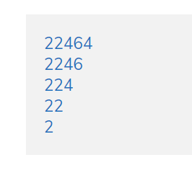

/\*\*

\* C program to print the given number pattern

\*/

#include <stdio.h>

int main()

{

int num;

printf("Enter any number: ");

scanf("%d", &num);

while(num != 0)

{

printf("%d\n", num);

num = num / 10;

}

return 0;

}

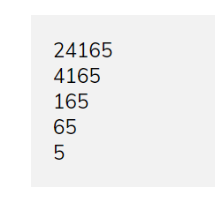

/\*\*

\* C program to print the given number pattern

\*/

#include <stdio.h>

#include <math.h>

int main()

{

int num, firstDigit, digits, placeValue;

printf("Enter any number: ");

scanf("%d", &num);

while(num > 0)

{

printf("%d\n", num);

digits = (int) log10(num); // Get total number of digits

placeValue = (int) ceil(pow(10, digits)); // Get the place value of first digit

firstDigit = (int)(num / placeValue); // Get the first digit

num = num - (placeValue \* firstDigit); // Remove first digit from number

}

return 0;

}

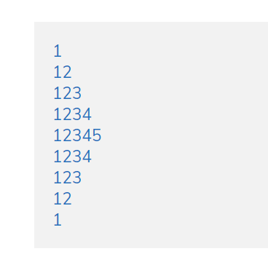

/\*\*

\* C program to print the given number pattern

\*/

#include <stdio.h>

int main()

{

int i, j, N;

printf("Enter N: ");

scanf("%d", &N);

// Prints upper part of the pattern

for(i=1; i<=N; i++)

{

for(j=1; j<=i; j++)

{

printf("%d", j);

}

printf("\n");

}

// Print lower part of the pattern

for(i=N-1; i>=1; i--)

{

for(j=1; j<=i; j++)

{

printf("%d", j);

}

printf("\n");

}

return 0;

}

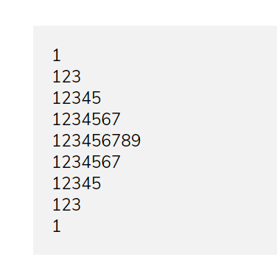

/\*\*

\* C program to print the given number pattern

\*/

#include <stdio.h>

int main()

{

int i, j, N;

printf("Enter N: ");

scanf("%d", &N);

// Iterate through upper half triangle of the pattern

for(i=1; i<=N; i++)

{

for(j=1; j<=(i \* 2 - 1); j++)

{

printf("%d", j);

}

printf("\n");

}

// Iterate through lower half triangle of the pattern

for(i=N-1; i>=1; i--)

{

for(j=1; j<=(i \* 2 - 1); j++)

{

printf("%d", j);

}

printf("\n");

}

return 0;

}

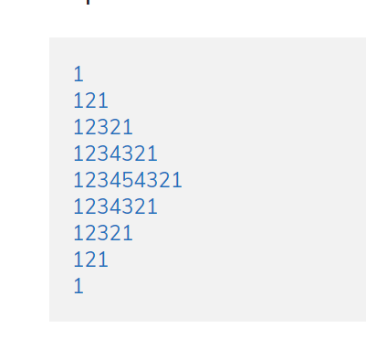

/\*\*

\* C program to print half diamond number pattern series

\*/

#include <stdio.h>

int main()

{

int i, j, N;

printf("Enter rows: ");

scanf("%d", &N);

// Print the first upper half

for(i=1; i<=N; i++)

{

for(j=1; j<=i; j++)

{

printf("%d", j);

}

for(j=i-1; j>=1; j--)

{

printf("%d", j);

}

printf("\n");

}

// Print the lower half of the pattern

for(i=N-1; i>=1; i--)

{

for(j=1; j<=i; j++)

{

printf("%d", j);

}

for(j=i-1; j>=1; j--)

{

printf("%d", j);

}

printf("\n");

}

return 0;

}

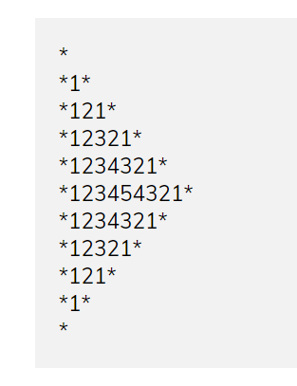

/\*\*

\* C program to print the half diamond number pattern with star border

\*/

#include <stdio.h>

int main()

{

int i, j, N;

printf("Enter rows: ");

scanf("%d", &N);

printf("\*\n");

// Print the first upper half

for(i=1; i<=N; i++)

{

printf("\*");

for(j=1; j<=i; j++)

{

printf("%d", j);

}

for(j=i-1; j>=1; j--)

{

printf("%d", j);

}

printf("\*");

printf("\n");

}

// Print the lower half of the pattern

for(i=N-1; i>=1; i--)

{

printf("\*");

for(j=1; j<=i; j++)

{

printf("%d", j);

}

for(j=i-1; j>=1; j--)

{

printf("%d", j);

}

printf("\*");

printf("\n");

}

printf("\*");

return 0;

}

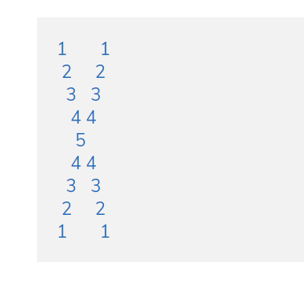

/\*\*

\* C program to print X number pattern

\*/

#include <stdio.h>

int main()

{

int i, j, N;

printf("Enter N: ");

scanf("%d", &N);

// First part of the pattern

for(i=1; i<=N; i++)

{

// Print trailing spaces

for(j=1; j<i; j++)

{

printf(" ");

}

printf("%d", i);

// Print central spacces

for(j=1; j<=((N - i) \* 2 - 1); j++)

{

printf(" ");

}

// Don't print for last row

if(i != N)

printf("%d", i);

// Moves on to the next row

printf("\n");

}

// Second part of the pattern

for(i=N-1; i>=1; i--)

{

// Print trailing spaces

for(j=1; j<i; j++)

{

printf(" ");

}

printf("%d", i);

// Print central spaces

for(j=1; j<=((N - i ) \* 2 - 1); j++)

{

printf(" ");

}

printf("%d", i);

// Move on to the next line

printf("\n");

}

return 0;

}